Joining the video room

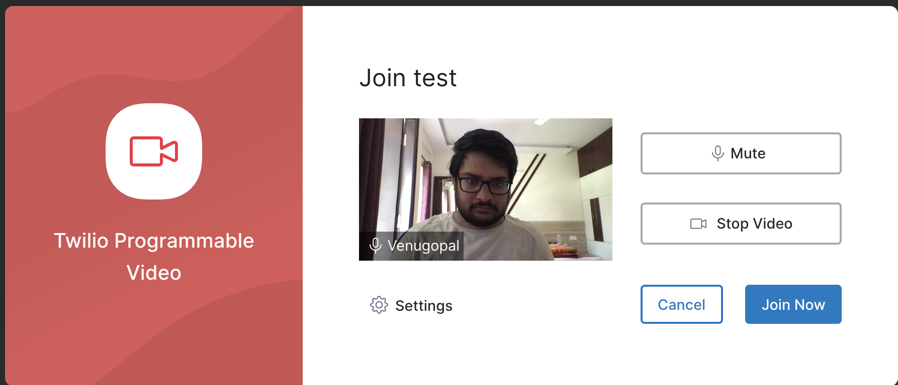

Room SID - RMe1b0eaf5072dd12c1726ce587a64cb29, RM5d3240e93264e9578c54f7889062a4d0

Configuring the audio and video setting

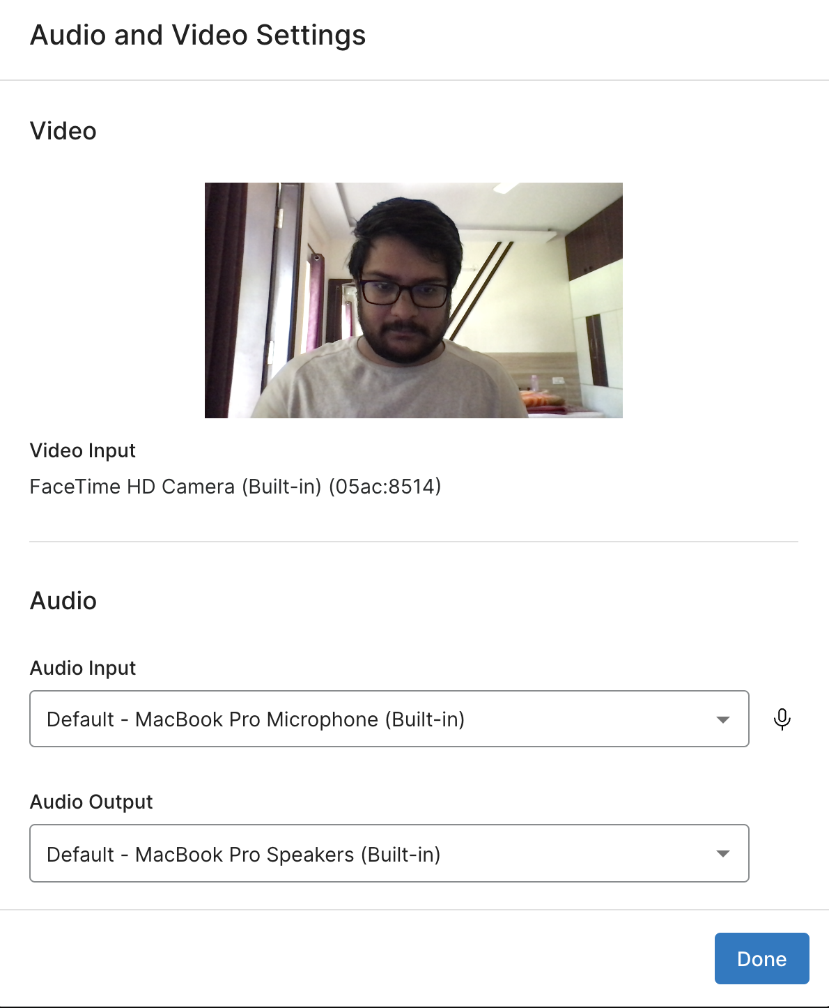

The recording has begun

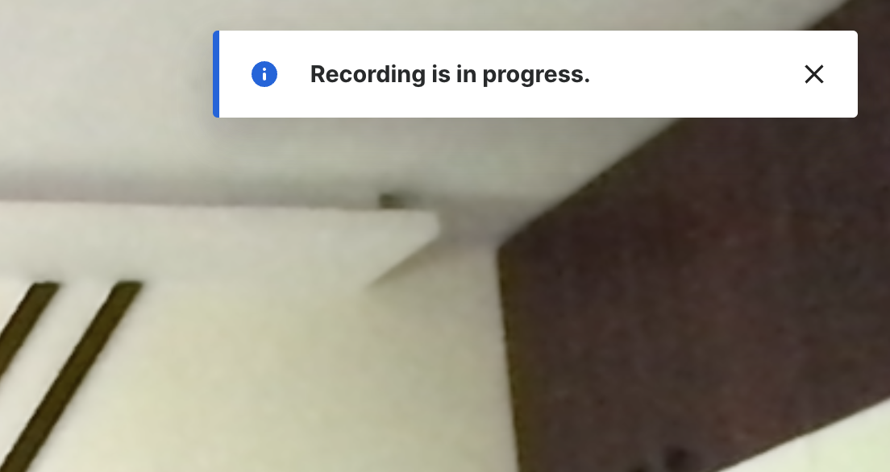

Adding background filter



Stopped the recording and message popped saying recording is completed.

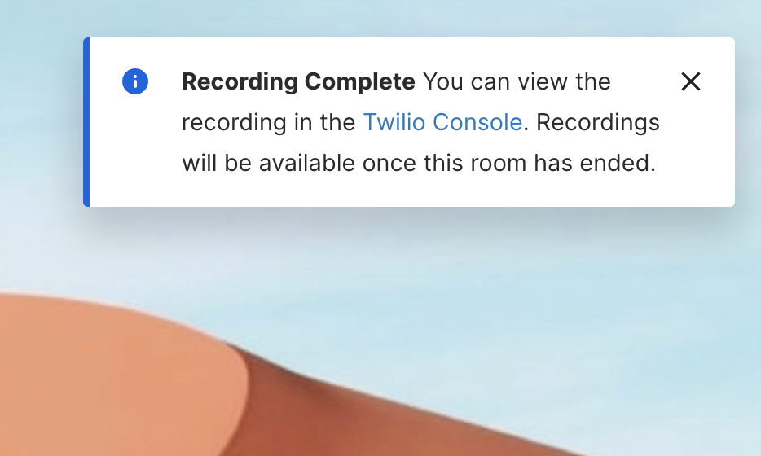

Room Information

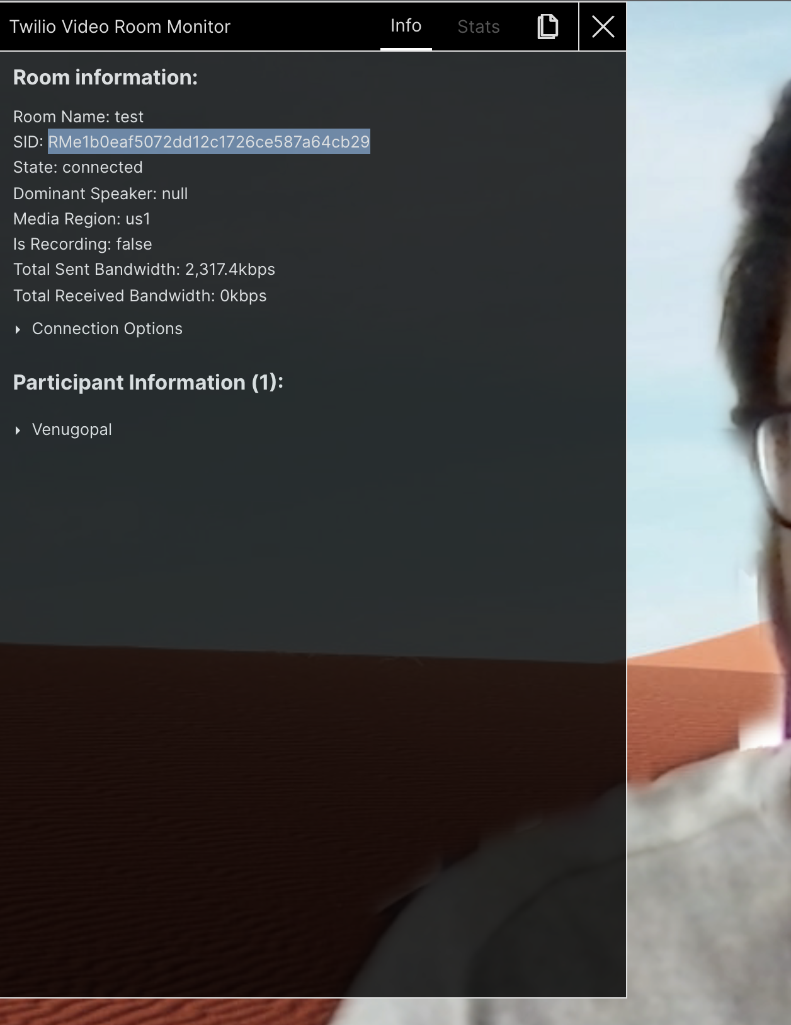

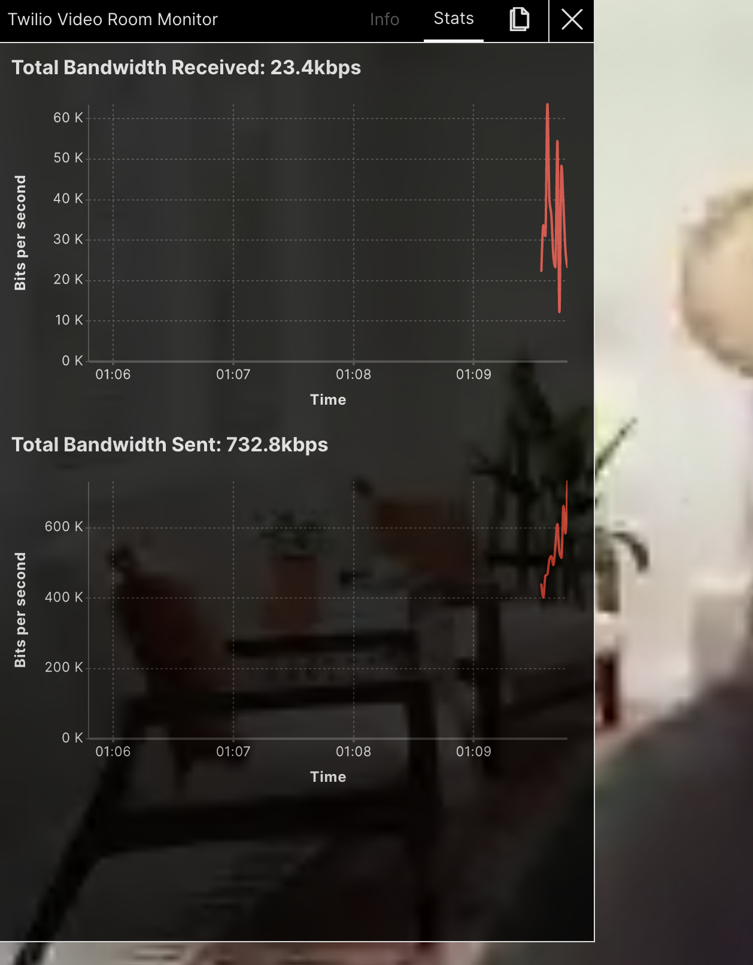

Created a group room with another participant. Started a chat, shared attachments and screen.

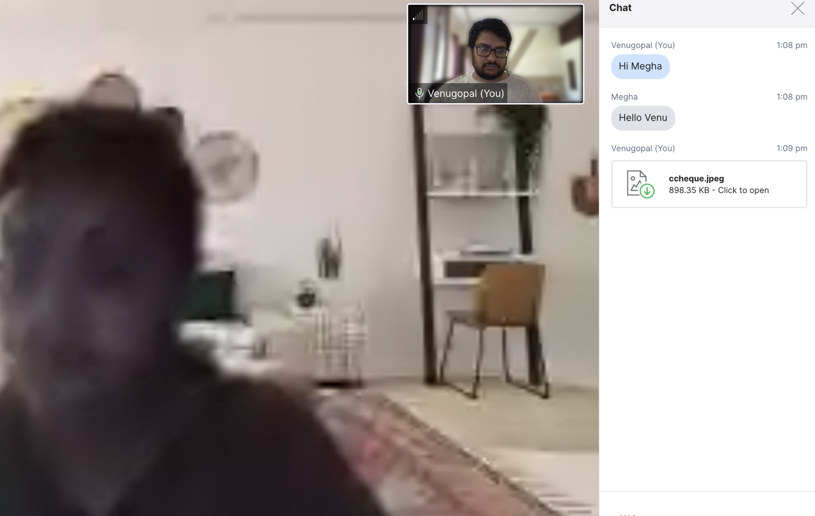

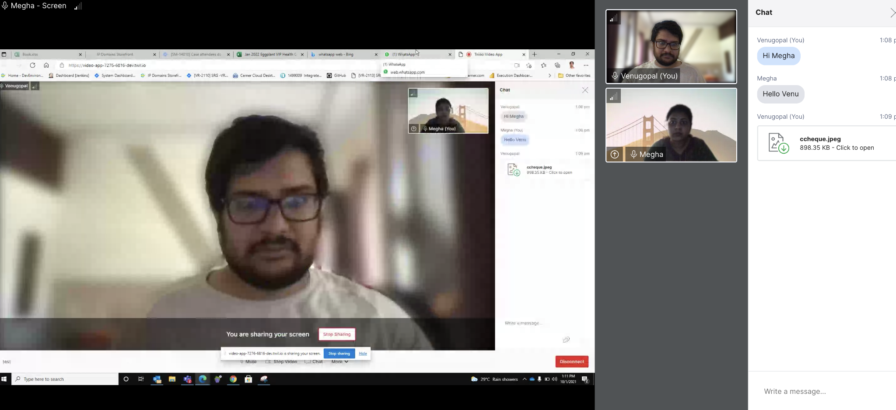

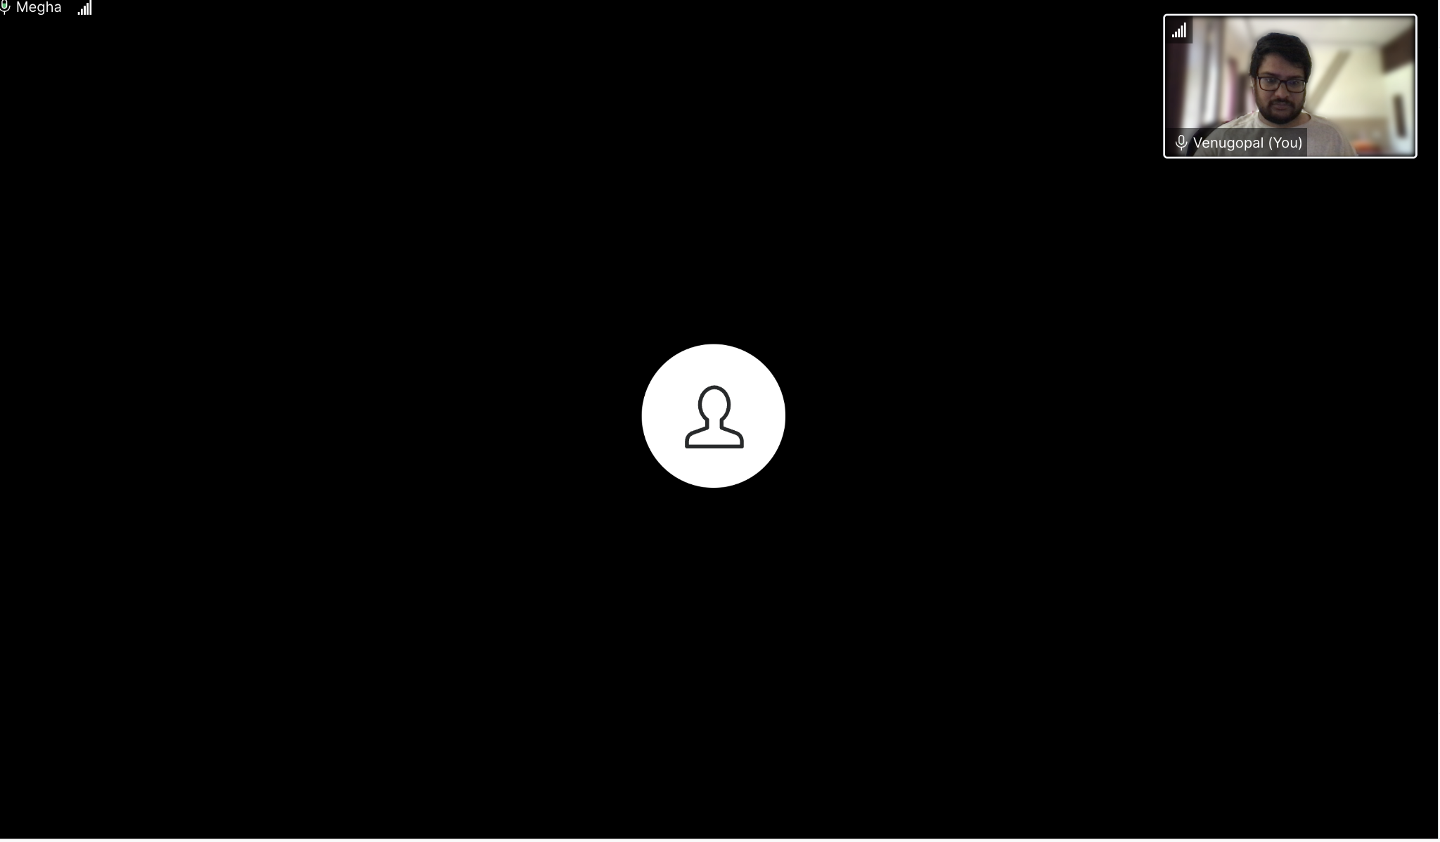

Added crisp to the audio input selector

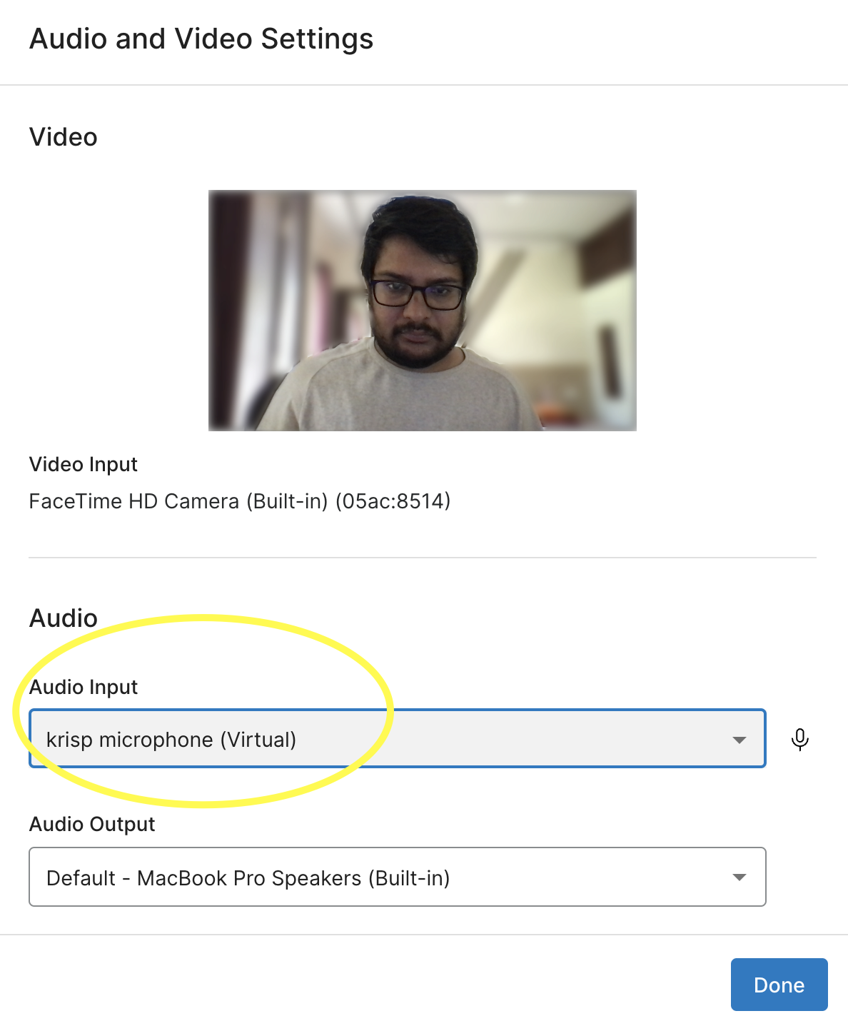

Voice call to video room

RMc738550ed80dc9021f85eecc7a468e62

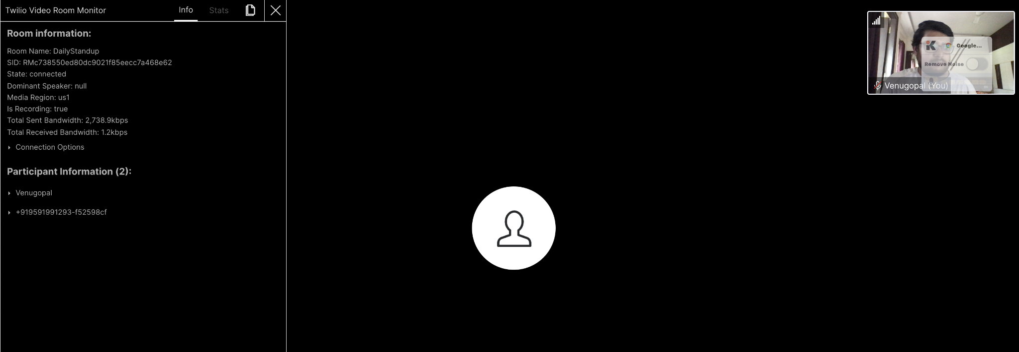

Peer-to-peer Room - RM6d1b700a1472a3e00cdd82a1b695f1e9

